LangChain Vs LangGraph
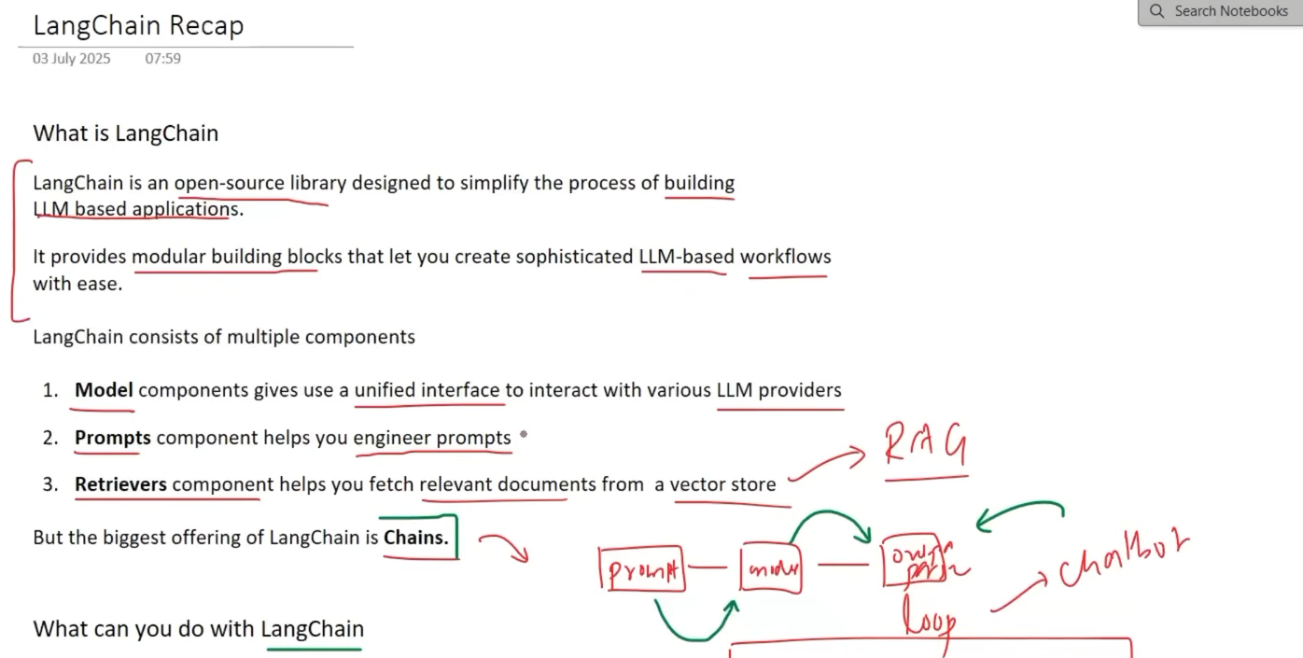
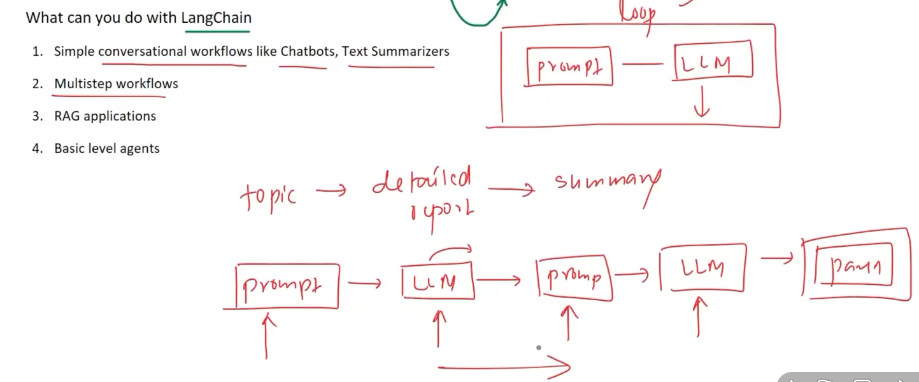
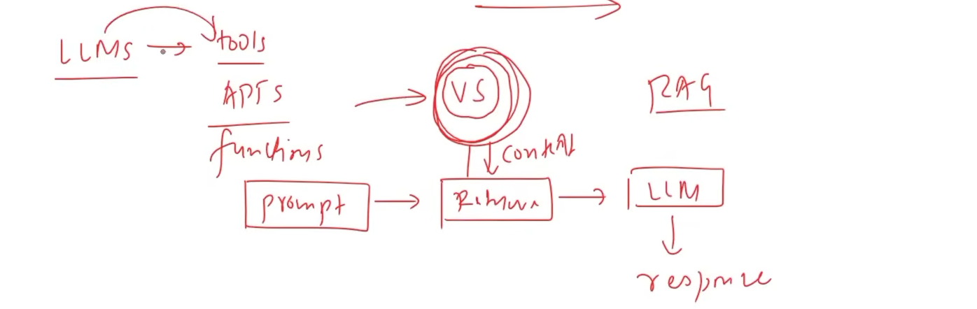
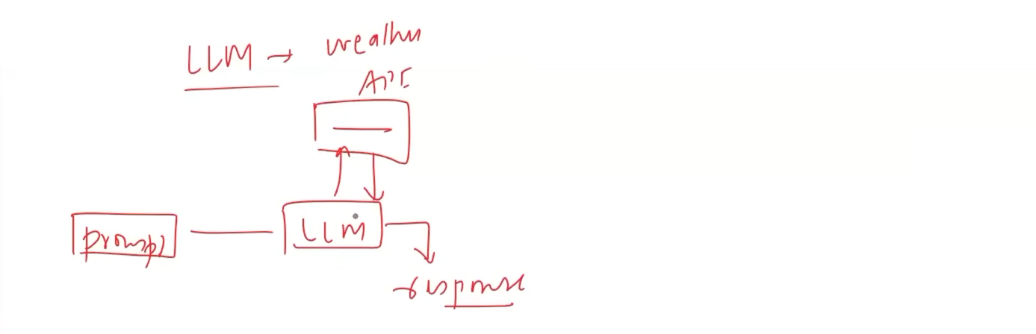

Difference between agents and workflow :- Workflow: A predefined sequence of operations to accomplish a task.
Agent: An autonomous system that decides what actions to take and in what order to accomplish a goal.
Important: An agent can use workflows as tools/subroutines.
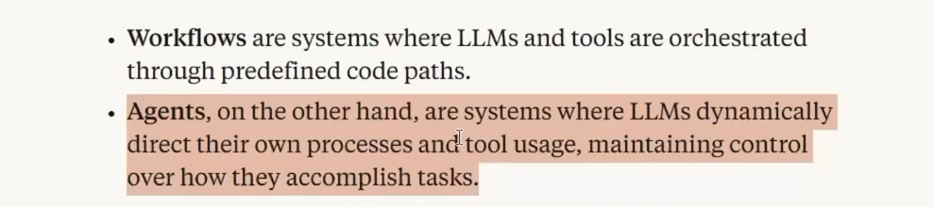

Workflow of a Automated Hiring Process :- We use this example to show what challenge the langraph is solving for langchain.
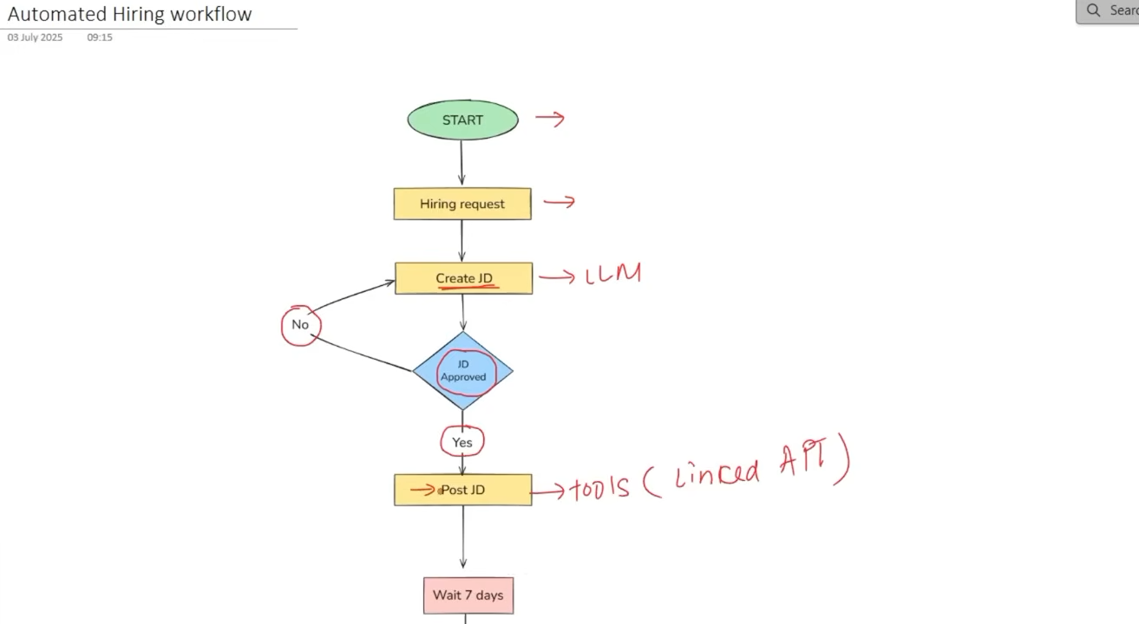

Lets assume that threshold is 20 application and if its less than 20 then we go left otherwise we move on.
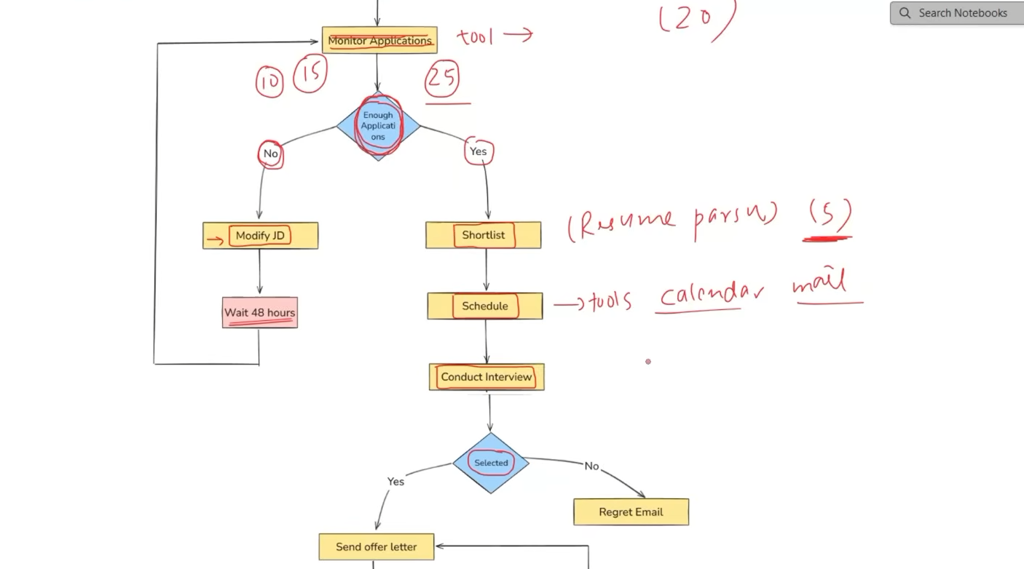
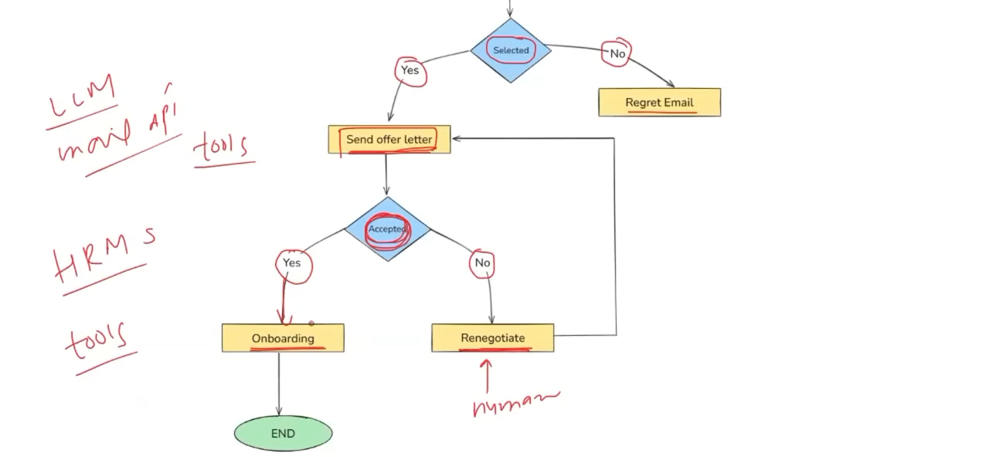
LangChain struggles with complex workflows because many conditions, loops, and jumps become difficult to manage.
LangGraph handles them better by representing the process as a graph, where nodes can loop, branch, and jump based on conditions.

We have these 3 things in the code which is an issue for langchain.
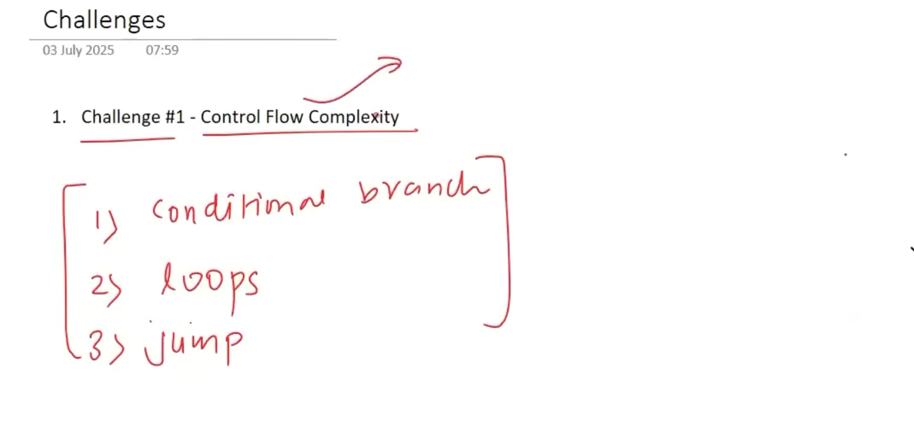

This is a code for starting part of the workflow.
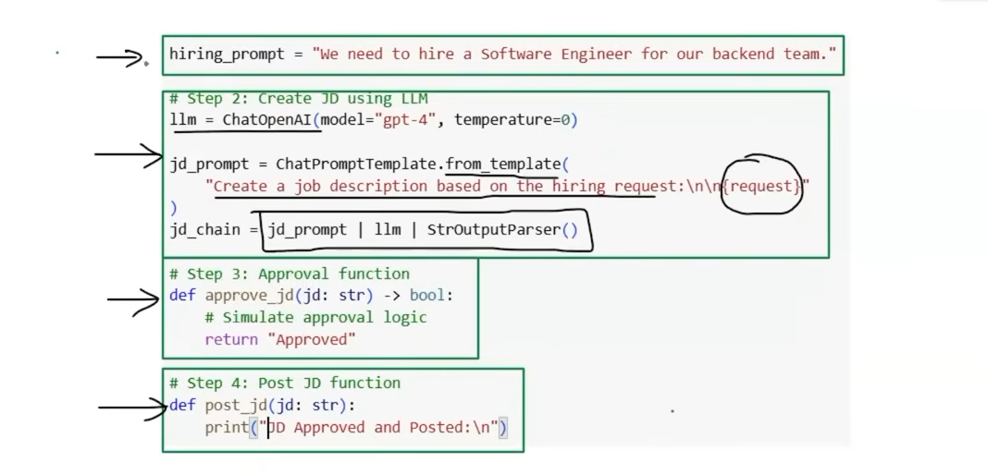

LangChain doesn't directly provide this looping logic, so we need to write custom code to connect everything.
Glue code = custom code written to make different components/libraries work together.
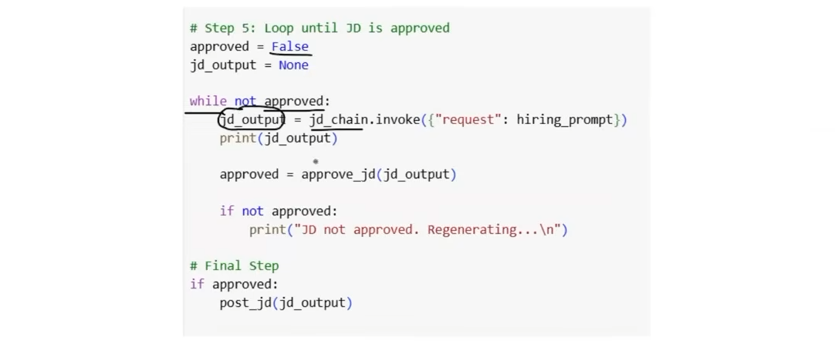
As the application grows, the amount of glue code grows too, making the system harder to maintain.
Problem with LangChain: It doesn't natively provide clear constructs for:
- 🔄 Loops
- 🔀 Conditional branching
- ↪️ Jumps
- 🔁 Non-linear workflows
So we end up writing glue code ourselves.

In LangGraph, we represent each task as a node and connect nodes using edges that define how the workflow moves.
Hiring Request
↓
Create JD
↓
Post JD
↓
Applications
↙ ↘
Reject Interview
- Nodes → functions/tasks
- Edges → define what happens next
- Conditional edges → make decisions/branches
- Loops → allow going back to an earlier node
- Graph structure → naturally supports non-linear workflows
Key idea
LangGraph provides the constructs for complex workflow logic, so we don't need to build large amounts of glue code ourselves.
Intuition: Instead of manually writing code to control “if this happens, jump there, then loop back”, we draw those relationships directly into the graph
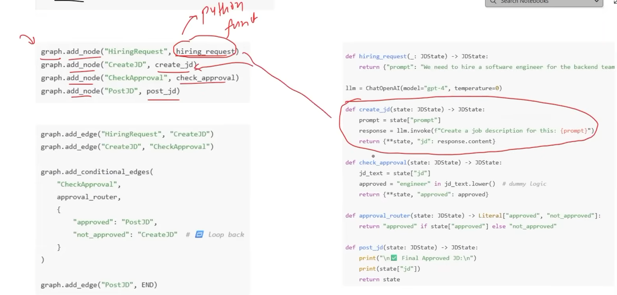

In LangGraph, State is the shared data/memory that stores the current information of the graph as it moves from one node to another. It basically stores those changes and is a common variable which all nodes can access to find the current state of the workflow.
Each node reads the state, does something, and can update the state.
Intuitively:
State = the graph's current memory/context.
Problem with LangChain: It doesn't have a built-in, structured mechanism for managing changing state.
You may have to:
- Store information as text, or
- Maintain a dictionary manually and update it yourself.
As the application grows, this becomes difficult to manage.
Intuition
LangChain
State → manually manage dictionary → update everywhere ❌

LangGraph
State → structured shared state → nodes read/update it ✅
LangGraph treats state as a first-class concept, making it easier to track and update information as the graph executes.

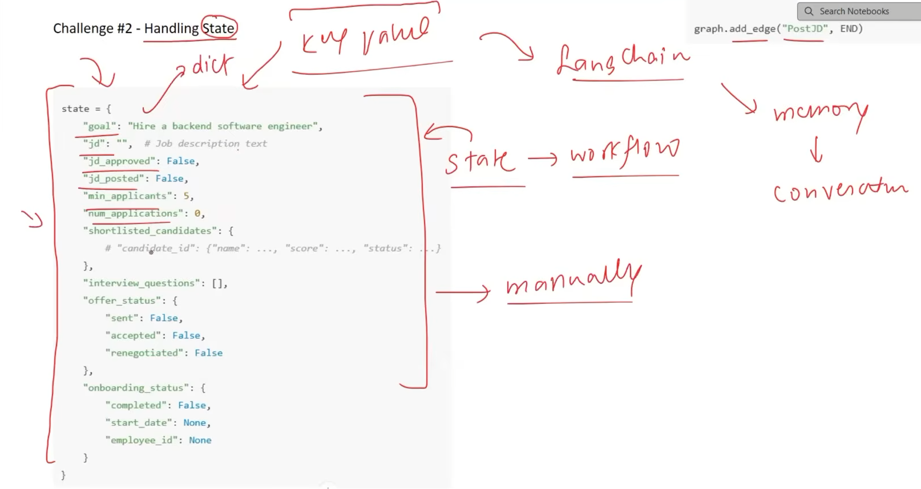
It will be hard to handle a workflow if the state is a mess and isn’t tracked properly.

Stateful means a system remembers and maintains information from previous steps/interactions.
Intuitively:
- Stateless: Every request starts fresh
- Stateful: Remembers what happened before
Example:
A chatbot that remembers “My name is Prajyot” in the next message is stateful.
In LangGraph, the graph is stateful because it maintains a State as execution moves between nodes. Langchain is stateless.

LangGraph uses a structured State defined with TypedDict or Pydantic.
State = a shared memory 📒 for all nodes.
- Every node can read the State.
- Nodes can update the State.
- Updated State moves through the graph.
- No need to manually pass data between every node.
Intuition: Nodes work on the same shared notebook as the workflow progresses.

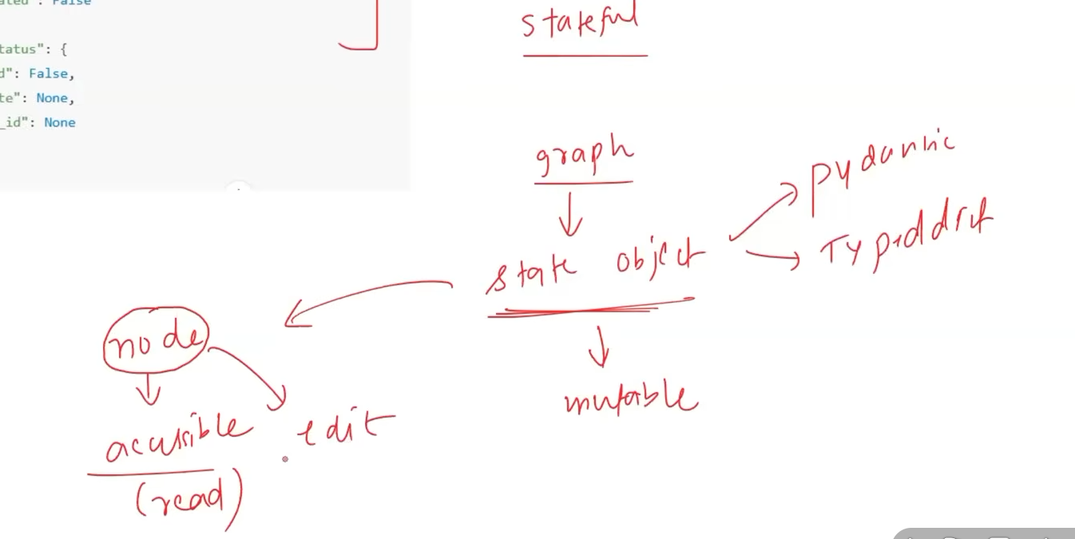

A node can execute when its triggering condition/event occurs, such as receiving an updated state or being reached by another node.

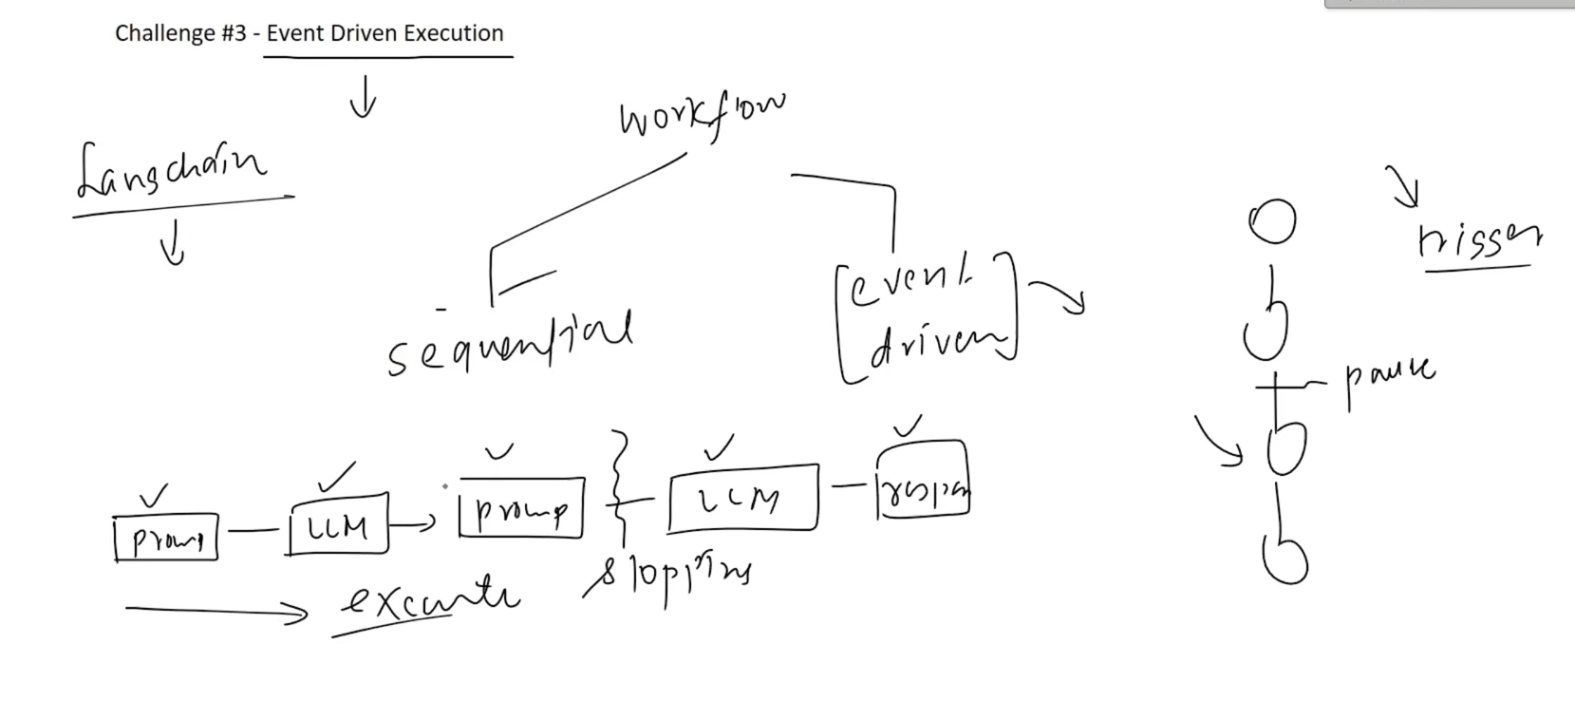
Event-Driven Execution
LangChain: You would need two separate chains + external Python code to wait for 7 days and trigger the second chain. This creates glue code.
LangGraph: The graph can save its current state using a checkpoint, pause, wait for an external trigger, and then resume from where it stopped.
Intuition:
LangChain: Stop → external code waits → start again
LangGraph: Save → wait → trigger → resume

Fault tolerance in LangGraph means the graph can handle failures in a node/tool and continue or recover without losing the overall execution state.
Its mainly made for big and complex problems.
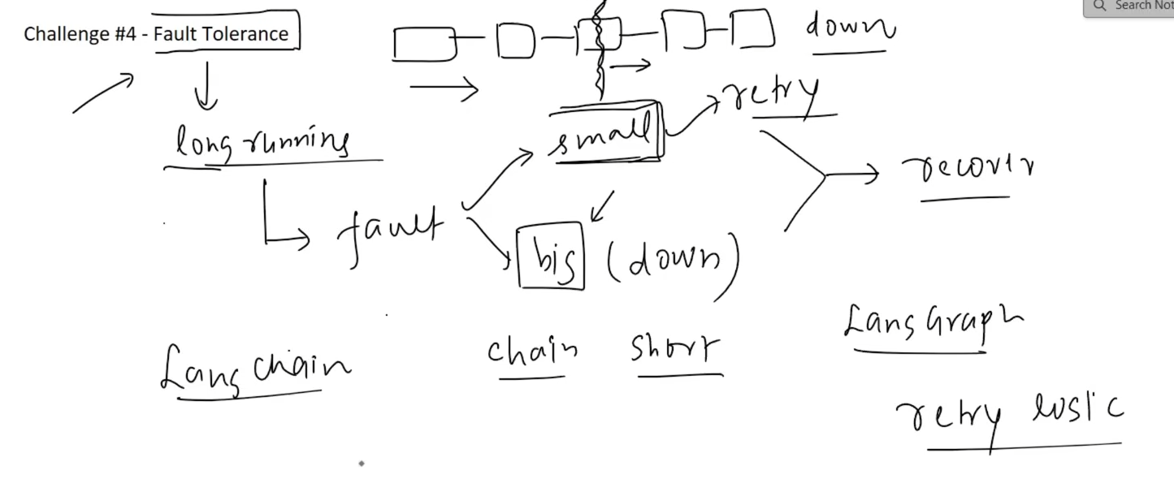
LangChain: If the system fails in the middle of a chain, it generally loses the current progress and you may need to start again from the beginning.

LangGraph can recover from a failure using checkpoints.
It saves the current state in a checkpoint. If something fails, the resume process uses that saved state to continue execution from that point instead of starting over.
Intuition:
Failure → Restore checkpoint → Resume with saved state → Continue

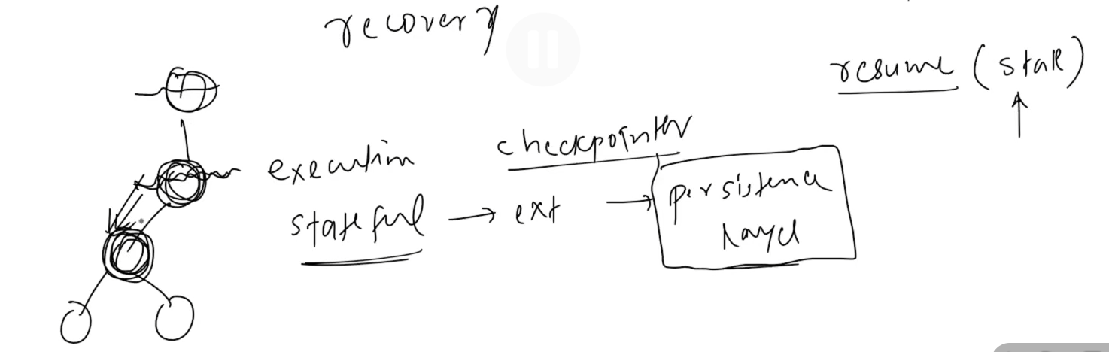
Persistent layer = the mechanism that stores the graph’s state/progress so it can be recovered later.

angChain: Human input can be added manually, but if the system waits for days, the chain may remain active and waste resources. Alternatively, using two chains requires glue code to pass data from the first chain to the second.
LangGraph: Can pause the workflow, save its state, release resources, wait for human input, and resume later.
Intuition:
Run → ⏸️ Save state → Free resources → Human responds → Resume
LangGraph is better suited for long-running workflows that need human intervention.

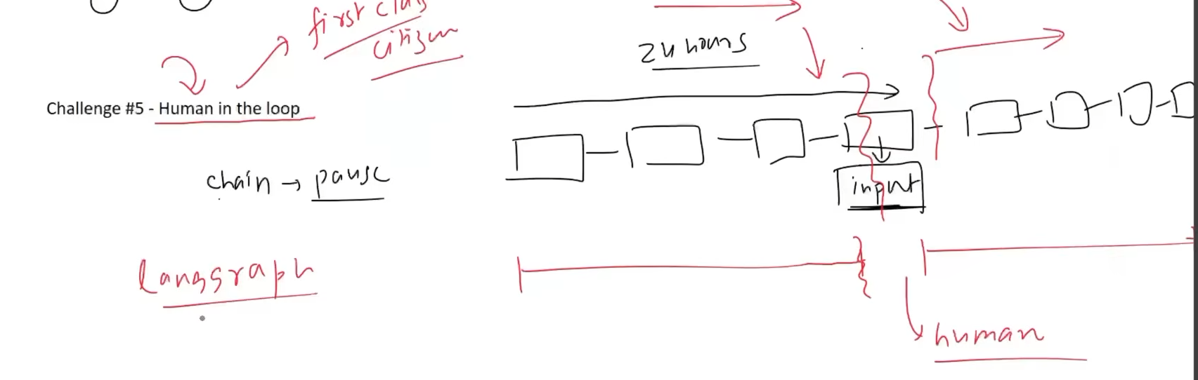

A subgraph is a LangGraph graph used as a node inside another (parent) graph.
Main Agent
- 🔍 Research subgraph
- 📝 Writing subgraph
- ✅ Review subgraph
Subgraphs are especially useful for multi-agent systems because you can make each agent a separate subgraph with its own logic.

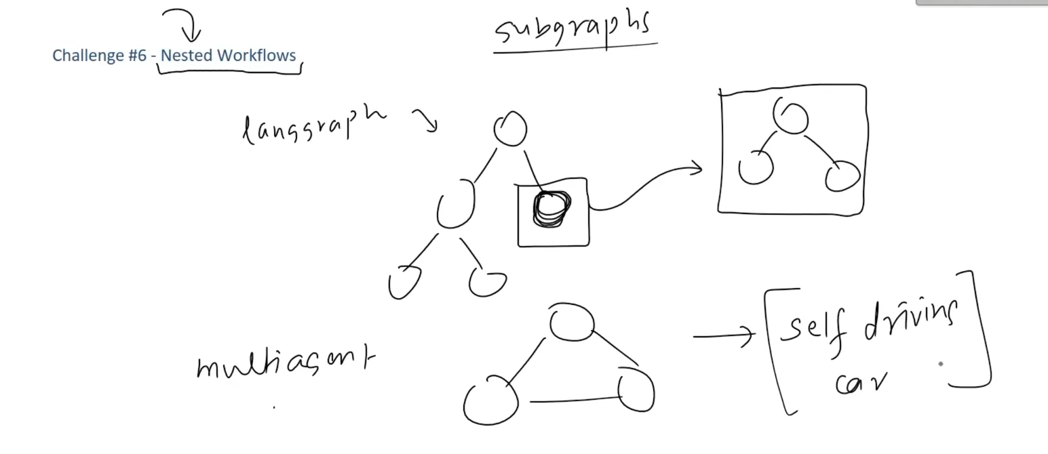
We can even RE-USE the sub-graphs at different places and agents.
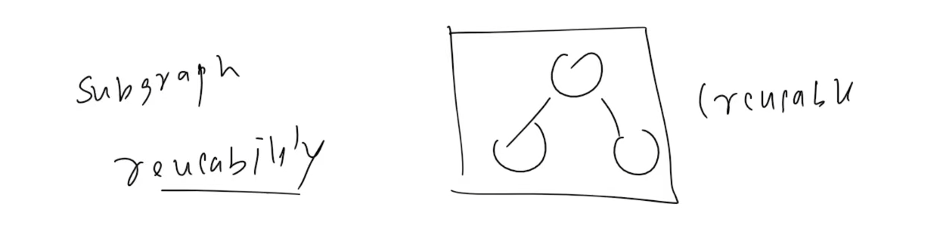

LangSmith can monitor what happens inside LangChain — model calls, queries, responses, token usage, etc.
But it cannot automatically observe the external glue code you write around LangChain.
Intuition:
LangChain → LangSmith can track ✅
Glue Code → LangSmith can't track directly ❌
So, the more glue code you have, the more of your application's execution becomes invisible to LangSmith.
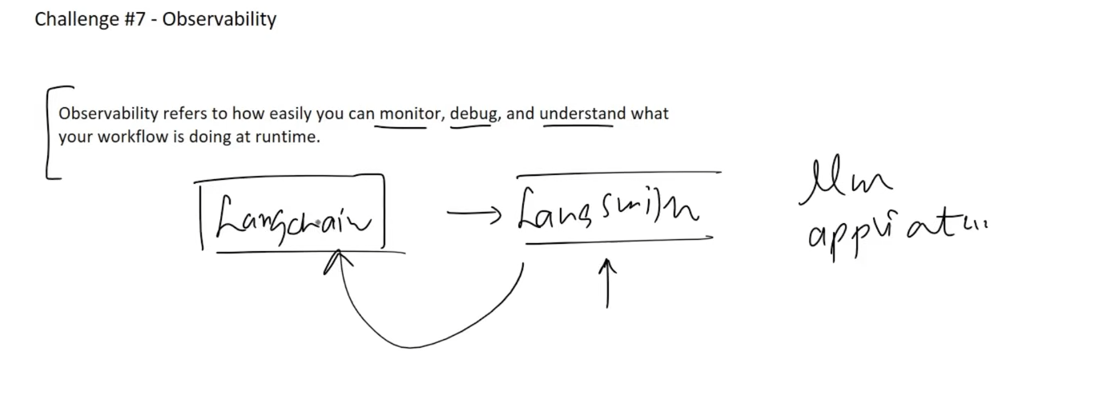
LangGraph can connect with LangChain and works closely with LangSmith.
- LangSmith gets information about the entire graph execution:
  - State before/after nodes
  - Message exchanges
  - Human approval points
  - Node execution
- This creates a timeline of execution that can be used to trace and backtrack.
LangChain: Provides only partial observability because external glue code is not tracked.

Summary :-
